Всероссийская олимпиада школьников по английскому языку 2019–2020 уч.г
.Школьный этап. 5–6 классы
Script
Listen to the text and choose the right answer A, B or C. You will hear the text twice.
The Matryoshka Doll's house
The Russian Matryoshka Museum is home to a collection of 400 Matryoshka dolls. These date from the 19th century up to the present day. The dolls are wooden with beautiful decorations. Some of them represent characters from Russian literature, fairy tales and politics. Most of the dolls have five to seven pieces, but some sets are really big and have fifty pieces. The biggest piece is one metre high and the smallest one is one centimetre high.
The History of the Matryoshka Doll
The Matryoshka doll came to Russia from Japan at the end of the 19th century. The first Matryoshka was a girl in a print dress, a white apron and a bright shawl, carrying a rooster under her arm. There were six other dolls inside her. The doll looked very Russian and soon became popular. The name Matryoshka came from the common Russian name Matryona. Today, Matryoshkas are made in many parts of Russia.
Where to find us
The museum is at 7, Leontievsky Pereulok in Moscow between Tverskaya and Nikitskaya Streets. Everyone is welcome.
Now you have 20 seconds to answer the questions. (Пауза 20секунд) Now you will hear the text again (Повторение записи). You have 20 seconds to check your answers. (Пауза 20 секунд). This is the end of Part 1.
КЛЮЧИ
Part 1 Listening 5 баллов
1 | 2 | 3 | 4 | 5
B | C | A | B | C

Part 2 Reading 12 баллов
Task 1
1 | 2 | 3 | 4 | 5 | 6 | 7
C | F | B | G | A | D | E

Task 2
8 | 9 | 10 | 11 | 12
D | F | B | E | C

Part 3 Use of English 43 балла
Task 1
1 | like | 12 | couldn't see
2 | shall/will/’ll tell | 13 | had already gone
3 | was reading | 14 | stayed
4 | entered/had entered/’d entered | 15 | is/’s
5 | turned | 16 | was just looking
6 | heard | 17 | smiled
7 | is/’s | 18 | happens
8 | called | 19 | will/shall/’ll let
9 | dropped | 20 | know
10 | ran | 21 | turned
11 | came | 22 | left

Task 2
23 | 24 | 25 | 26 | 27 | 28 | 29 | 30 | 31 | 32
C | B | C | B | D | C | A | D | D | B

Task 3
33 | love
34 | friend
35 | put
36 | wear
37 | laugh

Task 4
38 | 39 | 40 | 41 | 42 | 43
G | F | E | B | D | A

Максимум за работу - 60 баллов
Всероссийская олимпиада школьников по английскому языку 2019–2020 уч. г.
Школьный этап. 7–8 классы
Part 1 Listening
Script
Listen to the first part of the lecture and decide which statements 1–9 are True (T), False (F ) or Not Stated (NS). You will hear the text twice. Now you have 30 seconds to read the questions. (Пауза30 сек). Now we are ready to start.
The rise of Moscovy (as the principality was named) was made possible due to several factors. First and foremost was its location in the area between the rivers at the crossroads of Russia’s trade routes. Another factor was its prestige as a seat of the Russian Orthodox Church, which became important after the fall of Constantinople in the 15th century. Moreover, during the 1350s, the Mongol-Tatar Golden Horde was weakened by numerous struggles for power within its vast empire. Meanwhile, the Kremlin was being strengthened.
In 1380, Dmitry led the Russian army to confront the Horde near the River Don. The battle of Kulikovo was the Russians’ first victory, and this historic event was commemorated by the foundation of the Donskoy Monastery on the site where Dmitry assumed the title of Donskoy. However, the Horde remained a serious threat.
In the years that followed, Russian icon painting reached its zenith. The names of the artists were Theopohanes the Greek, Andrei Rublyev and Daniil Cherniy, who worked in Moscow.
In 1453, the Byzantine capital Constantinople fell to the Turks.
You have 1 minute to fulfil the task. Then you will hear the text again. (Пауза1 минута). Now listen to the text again. (текст звучит еще раз)
This is the end of task 1.
Task 2
Listen to the second part of the lecture and fill in the gaps 10–17 in the text below. You will hear the recording only once. Now you have 30 seconds to read the questions. (Пауза 30 сек)
Now we are ready to start.
The Tatar Yoke was finally thrown off in the reign of Ivan III, Dmitry Donskoy’s grandson. He was known as Ivan the Great. He married Sophia Palaiologina, the niece of the last Emperor of Byzantium. She presented
the country with its coat-of-arms – a double-headed eagle. Ivan III used
it as a symbol of his claim to rule the Eastern and Western Roman Empires. So, Ivan’s marriage provoked the idea of Russia being one and only successor of the Great Constantinople and the only true defender of the Orthodox Church.
Having gained power over Yaroslavl, Rostov, Tver and Pskov before his marriage, Ivan III continued the expansion of Moscovy. By the end of his reign even independent Novgorod had submitted, giving Moscow control of a huge area that stretched as far north as the White Sea. Thus, he acquired the title
of the “Gatherer of the Russian lands” and “Autocrat of all the Russians”.

KEYS
Part 1 Listening 17 points
1 | 2 | 3 | 4 | 5 | 6 | 7 | 8 | 9
T | NS | F | NS | T | F | NS | T | NS

Task 2
10 | 11 | 12 | 13 | 14 | 15 | 16 | 17
reign | married | presented | symbol | defender | expansion | control | title

Part 2 10 points
Reading Task 1
1 | 2 | 3 | 4 | 5 | 6 | 7 | 8 | 9 | 10
k | l | c | b | f | i | d | a | g | j

Part 3 Use of English 33 points
Task 1
0 | was doing | 8 | snatch | 16 | have/’ve found
1 | thought | 9 | could not/ couldn’t | 17 | come
2 | would /’d like | 10 | react | 18 | will/’ll be able
3 | went | 11 | had already disappeared | 19 | hurried
4 | took | 12 | had been robbed | 20 | was talking
5 | laid | 13 | had happened | 21 | was opening
6 | was brought | 14 | would/’d be found | 22 | had phoned
7 | was enjoying | 15 | rang | 23 | had taken away

Task 2
24 | 25 | 26 | 27 | 28 | 29 | 30 | 31 | 32 | 33
b | a | d | c | a | c | b | a | c | a

Task 3 Crossword 23 points
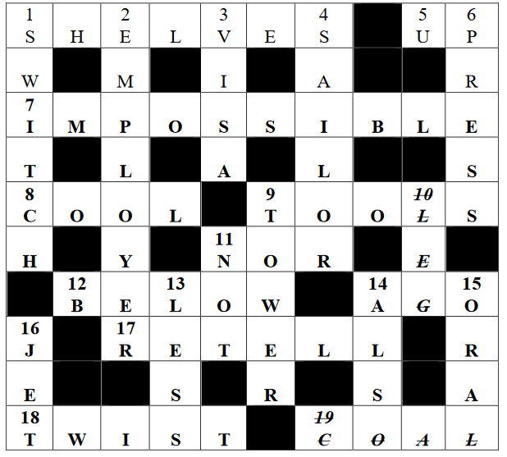
Максимум за работу – 83 балла

Всероссийская олимпиада школьников по английскому языку 2019–2020 уч. г.
Школьный этап. 9–11 классы
Keys
READING (15 points) LISTENING (10 points)
1 | A
2 | B
3 | A
4 | B
5 | B
6 | B
7 | A
8 | B
9 | C
10 | A
11 | C
12 | D
13 | D
14 | C
15 | A
1 | B
2 | B
3 | A
4 | C
5 | B
6 | A
7 | B
8 | A
9 | C
10 | B

USE OF ENGLISH (20 points)
1 | CHALLENGING
2 | MATURITY
3 | KNOWLEDGE
4 | SUCCESSFULLY
5 | SENSITIVE
6 | HELPFUL
7 | IMPORTANTLY
8 | DEVELOPMENTS
9 | UNABLE
10 | CONSTANTLY
11 | did not succeed in persuading
12 | to cut down on
13 | may have gone
14 | put up with
15 | only one/employee who did not
16 | no chance of winning
17 | would not have got
18 | apologised/apologized for yelling
19 | spite of not having
20 | with a view to becoming

Задания проверяются по ключам. Каждый правильный ответ оценивается в 1 балл.
За неверный ответ или отсутствие ответа выставляется 0 баллов. Орфография учитывается. Если допущена орфографическая ошибка в ответе, балл не начисляется.
Максимум за работу - 45 баллов.

